1. Git clone

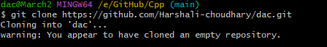

1. Git Status

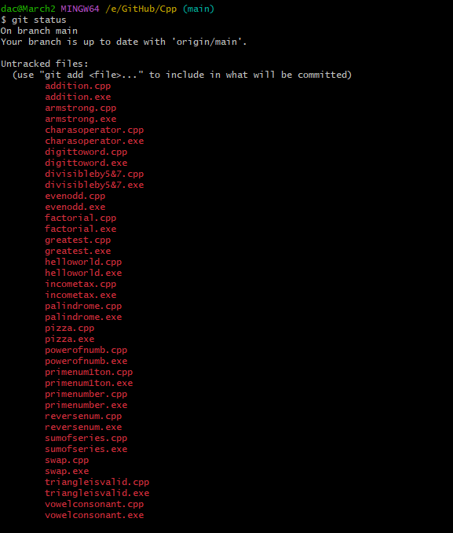

3.Add file to git



4 Git commit

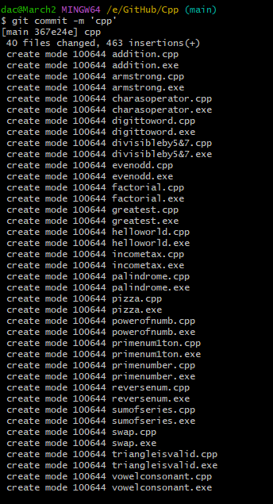

5.git push

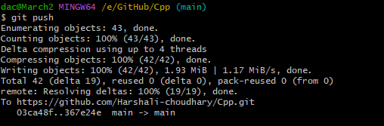

6. How to create branch ?

1. Git checkout



2.git branch

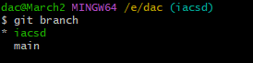

7. How to merge file ?

1. git checkout

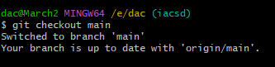

2.git merge

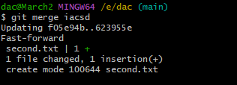

8. How to create backlog ?

1. go to backlog click on the create issue

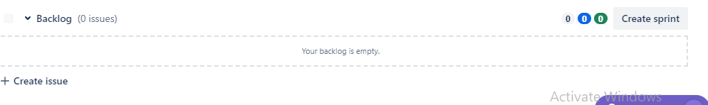

2. after click on issue create user stories

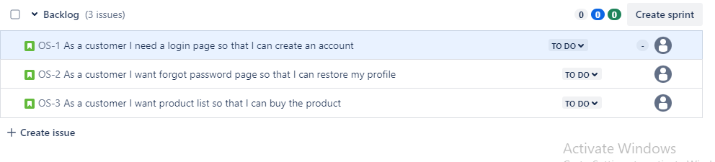

3 Create sprint and add user stories in it by select and drag it.

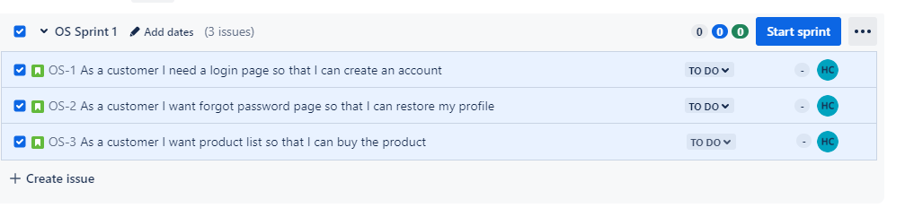

4 after adding user stories start the sprint

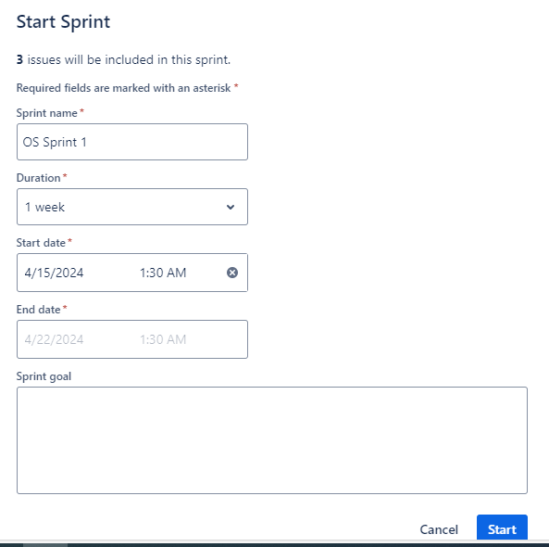

5 The user stories add in the to do list

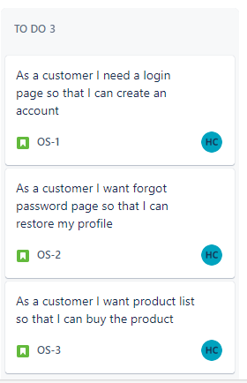

6. you start work on that user stories the user stories is go to in progress

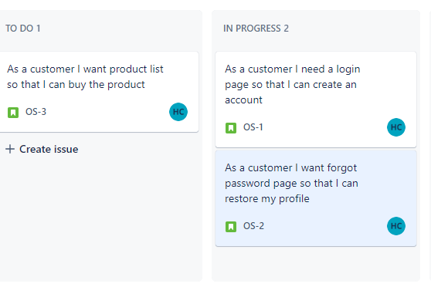

7. After resolve all the issue related to user stories the stories is goto done box

